CPS 510 - Database Systems I
Group 8
Assignment - 2

Amartya Chowdhury, 501153217
Mehrin Afroz Eshana, 501147157
Mohamad Al Walied Hasan Nafis, 501241332

This project involves designing a Database Management System (DBMS) for a clothing retail store. The system is intended to support essential business functions such as maintaining product information, managing customers and employees, processing orders and handling payments.

In Assignment 1, we described the scope and requirements of the system. Assignment 2 focuses on the logical database design, specifically the development of an Entity-Relationship (ER) Model. This report presents the ER diagram, describes the entities and relationships, and outlines key design decisions and assumptions.

Entities and Attributes
The following entities were identified for the system. Each entity has a primary key(PK), and foreign keys(FK) are indicated where relationships exist.

- category
PK: category_id
Attributes: name
- product
PK: product_id
Attributes: name, size, colour, brand, price, stock_qty
FK: category_id → category
- customer
PK: customer_id
Attributes: full_name, email, phone
- employee
PK: employee_id
Attributes: full_name, email, phone, role
- order
PK: order_id
Attributes: order_date, total_amount, order_status
FK1: customer_id → customer
FK2: employee_id → employee
- orderItem
PK: (order_id, product_id)
Attributes: qty, unit_price
FK1: order_id → order
FK2: product_id → product

- payment
PK: payment_id
Attributes: payment_method, total_amount, payment_status
FK1: order_id → order

Relationships and Cardinalities
The system includes the following relationships, expressed using crow’s-foot notation:
- category – products: one category can have many products; each product belongs to exactly one category.
- customer – order: one customer can place many orders; each order is placed by exactly one customer.
- employee – order: one employee can process many orders; each order is processed exactly by one employee.
- order – orderItem: each order must contain one or more items; each orderItem belongs to one order.
- product – orderItem: one product can appear in many orderItems; each orderItem refers to exactly one product.
- order – payment: one order may have zero or many payments; each payment is associated with one order

ER Diagram
The ER Diagram for the Clothing Retail Store DBMS is shown below. Entities, attributes, primary keys, foreign keys, and relationships are represented using crow’s foot notation.

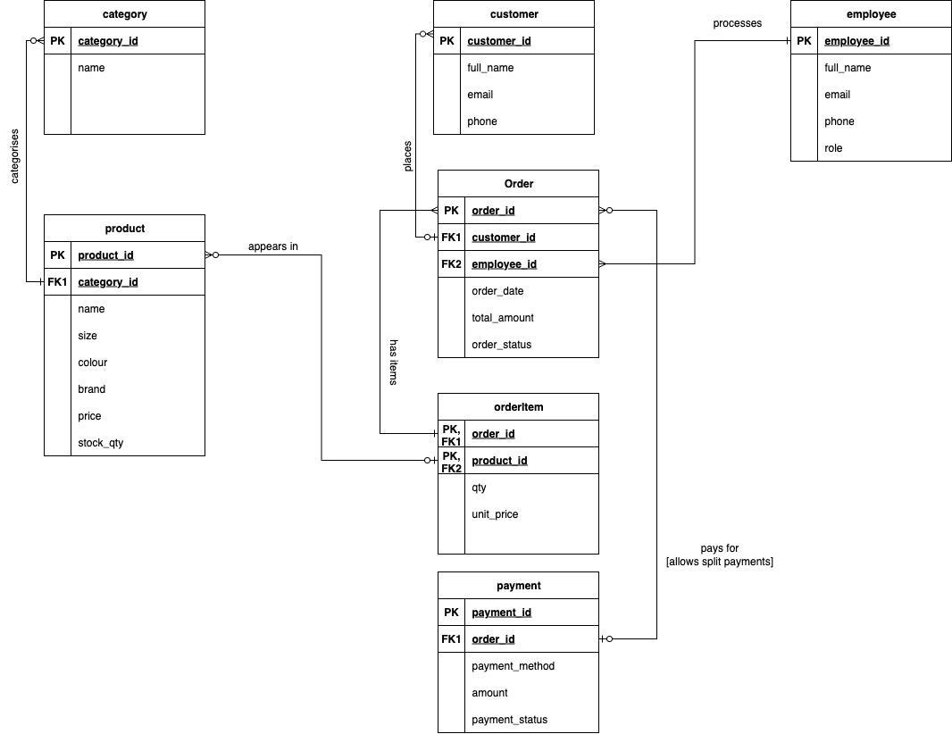

Figure 1: ER Diagram for Clothing Retail Store DBMS

Design Decisions and Assumptions
Several design decisions and assumptions were made during the modelling process:
- Refinement of A1: Compared to Assignment 1, we introduced the employee entity. This allows the system to track which staff member processes each order, improving operational traceability.
- Business rules:
  - Each order must contain at least one order item.
  - Product stock quantity (stock_qty) cannot be negative.
  - Payment methods are restricted to cash, credit and debit.
  - Orders may be paid using multiple partial payments.
- Naming conventions:
  - Singular entity names were used (e.g., Product, not Products).
  - Primary keys follow the format <entity>_id.
  - Foreign keys reference the corresponding primary key in the parent entity.

In conclusion, the ER model developed in this assignment provides a structured representation of the Clothing Store DBMS. It defines the entities, attributes, relationships, and business rules necessary to support the stores’ core operations.

This ER model will serve as the foundation for Assignment 3, where it will be translated into a relational schema in Oracle SQL with primary key, foreign key, and check constraints implemented.

